Regulatory Committee
Meeting to be held on 24 February 2016

Electoral Division affected:
Rossendale South

Wildlife and Countryside Act 1981
Definitive Map Modification Order Investigation
Upgrading from Public Footpath to Bridleway of Sales's Lane from County Boundary to Buckhurst Road and upgrading of Ramsbottom 245 from Sales's Lane to Croston Close Road, Ramsbottom, Rossendale Borough
File No. 804-547
(Annex ‘A’ refers)

Contact for further information:
Megan Brindle, 01772 535604, Paralegal Officer, Legal and Democratic Services,
megan.brindle@lancashire.gov.uk
Jayne Elliott, 07917 836626, Public Rights of Way, Planning & Environment Group,
Jayne.elliott@lancashire.gov.uk

Executive Summary

Application for Ramsbottom Footpath 208 (Sales's Lane) to be upgraded from footpath to bridleway from the County Boundary to Ramsbottom Footpath 207 (Buckhurst Road) and for Ramsbottom Footpath 245 to be upgraded from footpath to bridleway from Ramsbottom Footpath 208 (Sales's Lane) to Ramsbottom Footpath 206 (Croston Close Road), in accordance with file no. 804-547.

Recommendation

That the application in accordance with File Ref. 804-547 for Ramsbottom Footpath 208 (Sales's Lane) to be upgraded from footpath to bridleway be not accepted but instead the upgrade be to restricted byway.

That the application in accordance with File Ref. 804-547 for Ramsbottom Footpath 245 to be upgraded from footpath to bridleway be not accepted but instead the upgrade be to restricted byway.

That an Order be made pursuant to Section 53 (2)(b) and Section 53(3)(c)(ii) of the Wildlife and Countryside Act 1981 to upgrade Ramsbottom Footpath 208 (Sales's Lane) to Restricted Byway on the Definitive Map and Statement of Public Rights of Way as shown on the Committee Plans between points A-B-C-D-E-F-G-H-I.

That an Order be made pursuant to Section 53 (2)(b) and Section 53 (3)(c) (ii) of the Wildlife and Countryside Act 1981 to upgrade Ramsbottom Footpath 245 to Restricted Byway on the Definitive Map and Statement of Public Rights of Way as shown on the Committee Plans between points D-J-K-L.

That being satisfied that the test for confirmation can be met the Order(s) be promoted to confirmation.

Background

An application under Schedule 14 of the Wildlife and Countryside Act 1981 has been received from the Forest of Rossendale Bridleways Association to upgrade Ramsbottom Footpath 208 (known as Sales's Lane) from footpath to bridleway between the County Boundary and Ramsbottom Footpath 207 (Buckhurst Road) and shown between points A-B-C-D-E-F-G-H-I on the Committee plans and to upgrade Ramsbottom Footpath 245 from footpath to bridleway between Ramsbottom Footpath 208 (Sales's Lane) and Ramsbottom Footpath 206 (Croston Close Road) and shown between points D-J-K-L on the Committee plans. on the Definitive Map and Statement of Public Rights of Way.

The County Council is required by law to investigate the evidence and make a decision based on that evidence as to whether a public right of way exists, and if so its status. Section 53(3)(b) and (c) of the Wildlife and Countryside Act 1981 set out the tests that need to be met when reaching a decision; also current Case Law needs to be applied.

An order for upgrading a way shown on the Definitive Map and Statement will only be made if the evidence shows that:
- "it ought to be there shown as a highway of a different description"

An order for upgrading a way shown on the Definitive Map and Statement will be made if the evidence shows that:
- “the expiration… of any period such that the enjoyment by the public…raises a presumption that the way has been dedicated as a public path or restricted byway”

When considering evidence, if it is shown that a highway existed then highway rights continue to exist (“once a highway, always a highway”) even if a route has since become disused or obstructed unless a legal order stopping up or diverting the rights has been made. Section 53 of the Wildlife and Countryside Act 1981 (as explained in Planning Inspectorate’s Advice Note No. 7) makes it clear that considerations such as suitability, the security of properties and the wishes of adjacent landowners cannot be considered. The Planning Inspectorate’s website also gives guidance about the interpretation of evidence.

The County Council’s decision will be based on the interpretation of the evidence discovered by officers and documents and other evidence supplied by the applicant, landowners, consultees and other interested parties produced to the County Council before the date of the decision. Each piece of evidence will be tested and the evidence overall weighed on the balance of probabilities. It is possible that the Council’s decision may be different from the status given in any original application. The decision may be that the routes have public rights as a footpath, bridleway, restricted byway or byway open to all traffic, or that no such right of way exists. The decision may also be that the routes to be added or deleted vary in length or location from those that were originally considered.

Consultations

Rossendale Borough Council have been consulted and no response has been received, it is assumed they have no comments to make.

There is no Parish Council for this area.

Applicant/Landowners/Supporters/Objectors

The evidence submitted by the applicant/landowners/supporters/objectors and observations on those comments is included in ‘Advice – Head of Service – Legal and Democratic Services Observations’.

Advice

Head of Service – Planning and Environment

Points annotated on the attached Committee plan.

Point | Grid Reference (SD) | Description
A | 8127 1436 | Junction of Sales's Lane with Bentley Lane on County Boundary
B | 8138 1450 | Junction of Sales's Lane with Ramsbottom Footpath 232
C | 8153 1461 | Junction of Sales's Lane with Ramsbottom Footpath 252
D | 8167 1475 | Junction of Sales's Lane with Ramsbottom Footpath 245
E | 8180 1497 | Junction of Sales's Lane with Ramsbottom Footpath 231
F | 8184 1503 | Junction of Sales's Lane with Ramsbottom Footpath 235
G | 8192 1524 | No Horse riding sign positioned on Sales's Lane
H | 8192 1529 | Gates across Sales's Lane
I | 8191 1538 | Junction of Sales's Lane with Ramsbottom Footpath 207 (Buckhurst Road)
J | 8176 1464 | Bend in route
K | 8186 1463 | Junction of route with Ramsbottom Footpath 247 and access to Lark Mount
L | 8196 1462 | Junction of route with Ramsbottom Bridleway 206 (Croston Close Road)

Description of Route

A site inspection was carried out on 20th August 2015.

n.b. Reference to public rights of way shown on the Definitive Map and Statement are generally given in the form '14-3-FP208' or 'Ramsbottom Footpath 208' but are referenced below in the abbreviated form 'Footpath 208' for brevity since all those referred to are in Ramsbottom in Rossendale Borough.

The application seeks to upgrade two connecting routes that are both currently recorded on the Definitive Map and Statement as public footpaths.

Footpath 208, referred to as Sales's Lane – shown between points A-B-C-D-E-F-G-H-I on the Committee plans.

Sales's Lane commences at an unmarked point on the Lancashire/Bury county boundary at point A on the Committee plan.

A public footpath signpost is located close to point A pointing along Sales's Lane and indicating the legally recorded status of the route.

The start of Sales's Lane is not physically distinguishable from the 'end' of Bentley Lane – the public maintainable vehicular route which extends as far as the county boundary on the Bury side.

Bentley Lane is tarmacked and the tarmac continues through the county boundary at point A and along Sales's Lane at a width of approximately 2.8 metres. From point A Sales's Lane is bounded on the west by a substantial stone wall and on the east side a tarmacked route leaves Sales's Lane to extend steeply uphill to provide access to Gindles Farm.

Sales's Lane continues in a north easterly direction rising gradually uphill bounded on the west by a stone wall (broken in places) and to the east by an open ditch beyond which the land rises steeply.

The tarmac surface is in reasonable condition and during the course of the inspection several vehicles passed emphasising the difficulty of vehicles passing pedestrians, horse riders and cyclists.

At point B the route is crossed by Footpath 232 and a stone stile was evident in the wall on west side of the route.

The route continues from point B rising gradually uphill along the tarmac road and still bounded by wall on west side and open ditch to the east. At point C the route is joined by a further access road for Gindles Lodge.

From point C Sales's Lane continues in a north easterly direction with a wall along the west side and to the east a ditch and steep banking to point D at a junction with Footpath 245. Signs located at the junction positioned along both Sales's Lane and along Footpath 245 state 'Public Footpath No horseriding'.

From point D Sales's Lane continues in a north north easterly direction along the tarmac road enclosed on both sides between walls and fencing and approximately 2.8 metres wide. It continues past the entrance to Sales's Farm at point E as a tarmac road bounded on either side to the junction with footpath 235 at point F. The route then continues, still rising gradually uphill to point G where it widens as it passes through a corner adjacent to the remains of a small quarried area and a further sign is visible, located on the fencing stating 'No horseriding'.

From point G the route continues along the tarmac road in a northerly direction to Buckhurst Farm passing through double gates at point H. It then continues along the tarmac passing through farm buildings to meet Footpath 207 (Buckhurst Road) at point I.

The total length of the route is approximately 1250 metres.

Note: Footpath 207 (Buckhurst Road) was the subject of a separate application under the Wildlife and Countryside Act 1981 which was considered by the Regulatory Committee on 22 October 2014. An Order has recently been made to record this route as a restricted byway.

Footpath 245 – shown between points D-J-K-L on the Committee plan

The route leaves Sales's Lane at point D on the Committee plan which is an open and unrestricted junction. A sign is located adjacent to the route stating that it is a public footpath and specifying 'No horseriding'.

It extends in a south easterly direction tarmacked to a width of 2.8 metres and bounded on either side by a mixture of walls, hedging and fencing to point J where it turns to continue in a more east south easterly direction to point K where a vehicular access leaves the route on the north side to provide direct access to Lark Mount and Footpath 247 meets the route on the south side.

From point K the route under investigation continues as a tarmac road, still bounded on either side by a mixture of walls, hedging and fencing to point L where it joins Bridleway 206 (Croston Close Road) at an open junction.

The total length of the route is approximately 350 metres.

Map and Documentary Evidence

Document Title | Date | Brief Description of Document & Nature of Evidence
Yates’ Map  of Lancashire | 1786 | Small scale commercial map. Such maps were on sale to the public and hence to be of use to their customers the routes shown had to be available for the public to use. However, they were privately produced without a known system of consultation or checking. Limitations of scale also affected which routes could be shown.
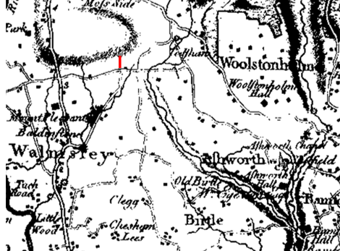
Observations |  | A route consistent with Sales's Lane and joining Buckhurst Road at point I is clearly visible with a property shown which, though not named, appears to be in the approximate location of Sales's Farm. The second route under investigation between points D-L is not shown on the map.
Investigating Officer's Comments |  | Sales's Lane existed in 1786 continuing from Bentley Lane (a public vehicular highway) past a property likely to be Sales's Farm to connect to Buckhurst Road at point I and appears to have formed a through route as part of the general road network. The depiction of the route on this commercially produced small scale map suggests that the route was considered to be public highway and travellers using such a map were likely to be on horseback or horse-drawn vehicle.  The route under investigation between points D- L is not shown suggesting that in 1786 it did not exist as a type of way the surveyor was recording.
Smith's Map | 1801 | Charles Smith was a London engraver and map seller. His map of Lancashire appeared as a single sheet in 1801 and then between 1804 and 1846 was published in subsequent editions of his new English Atlas. His map was similar to Cary's Map of Lancashire dated 1789 but is not a direct copy. It is thought that Smith and Cary used common sources, especially Yates' survey, and since both were aiming at the same market – the increasing number of private and commercial travellers – it is not considered surprising that they produced similar maps.
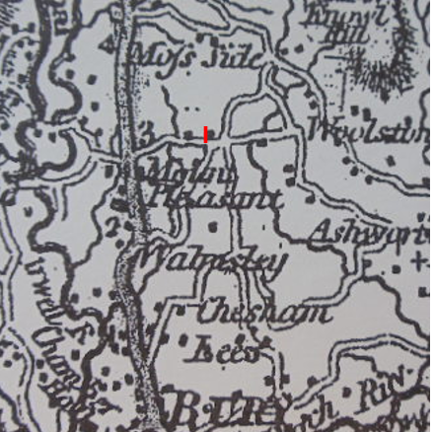
Observations |  | The whole of Sales's Lane is clearly shown as part of a longer route extending from Walmesley through to the junction with Buckhurst Road at point I. A property is shown south of point I which is consistent with the location of Sales's Farm.  Sales's Lane is depicted in the same manner as the general road network in the area.  The route between points D-L is not shown on the map.
Investigating Officer's Comments |  | Sales's Lane existed in 1801 and was shown on a map produced specifically to meet the needs of the travelling public as a through route, part of the general road network. Customers for this map would be travelling on horseback or horse drawn vehicles at that time.  The route between points D-L did not exist in 1801 as a type of way the surveyor was recording.
Greenwood’s Map of Lancashire | 1818 | Small scale commercial map. In contrast to other map makers of the era Greenwood stated in the legend that this map showed private as well as public roads and the two were not differentiated between within the key panel.
Observations |  | Unlike other early commercial maps examined Sales's Lane is not shown. The route between points D-L is also not shown.
Investigating Officer's Comments |  | Sales's Lane is shown on two earlier commercial maps and also on the private estate plan detailed below. It is therefore likely that this route existed in 1818 but may not have been considered by Greenwood to be a public carriageway.  The route between points D-L did not exist as a type of way recorded by the surveyor.
Survey of part of the Derby Estate | 1824 | A plan was submitted by the Applicant entitled 'Survey of part of the Derby Estate'. The copy of the plan originated from records held in the County Records Office (Reference DDK). Writing on the plan states that the original survey was carried out 1785-1788 and that the plan was dated 1824.
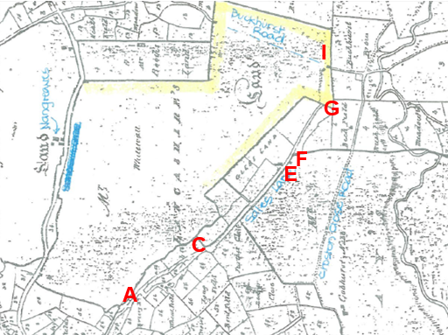
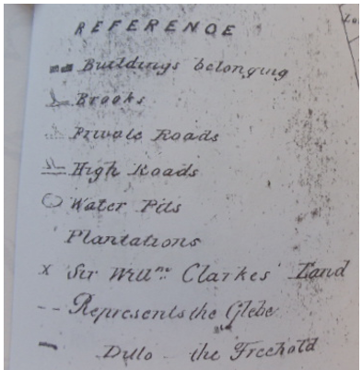
Observations |  | Sales's Lane is shown on the plan as a 'High Road' between points A-G. Between point G and point I it is shown as a double pecked line crossing an area of land described on the map as 'Mr Whitewall Lancashire's Land' within which buildings that now form part of Buckhurst Farm are shown connecting to Sales's Lane. Part of the route – from midway between point C and point E to point G is either bounded or forms part of the Glebe land labelled to the west of it (Glebe land was land owned in order to provide income, to pay parochial clergy).  The route between points D-L is not shown and neither is the property that is accessed from this route (Lark Mount).
Investigating Officer's Comments |  | Only a copy of the plan (and not the original) is available to view.  The purpose for which the plan was drawn is not known. The definition of 'High Road' is not given but it is clearly distinguished in the key from 'Private Roads' suggesting that a route shown as a High Road was likely to carry public vehicular rights. Part of Buckhurst Road – connecting to Sales's Lane at point I is not shown but this is considered to be more likely because it did not form part of Derby Estate rather than it not existing – especially if the section is shown to exist on other commercially produced maps from that time. This may also be the reason for the section of the route between point G and point I being shown as a double pecked line and not as a 'High Road'. The use of double pecked lines to denote a physical feature is not included in the map key and therefore it is inconclusive regarding whether this part of the route was considered as a high road, private or other. In practice it may have indicated that the route was not physically bounded or may have been depicted as such because it was outside the ownership of the Estate. It is unlikely simply to have changed status at that point.  The route D-L did not exist as a type of way recorded by the surveyor.
Hennet's Map of Lancashire | 1830 | A further small scale commercial map. In 1830 Henry Teesdale of London published George Hennet's Map of Lancashire surveyed in 1828-1829 at a scale of 7½ inches to 1 mile. Hennet’s finer hachuring was no more successful than Greenwood’s in portraying Lancashire’s hills and valleys but his mapping of the county's communications network was generally considered to be the clearest and most helpful that had yet been achieved.
Observations |  | Neither of the routes are shown on Hennet's Map.
Investigating Officer's Comments |  | It appears that neither of the routes were considered to be public carriageways by the surveyor at the time. The inclusion of Sales's Lane on earlier commercial and Estate plans suggests that it existed in 1830 but the route between points D-L may not have existed at that time.
Canal and Railway Acts |  | Canals and railways were the vital infrastructure for a modernising economy and hence, like motorways and high speed rail links today, legislation enabled these to be built by compulsion where agreement couldn't be reached. It was important to get the details right by making provision for any public rights of way to avoid objections but not to provide expensive crossings unless they really were public rights of way. This information is also often available for proposed canals and railways which were never built.
Observations |  | There are no canals or railways crossing the area investigated.
Investigating Officer's Comments |  | No inference can be drawn.
Tithe Map and Tithe Award or Apportionment | 1840 | Maps and other documents were produced under the Tithe Commutation Act of 1836 to record land capable of producing a crop and what each landowner should pay in lieu of tithes to the church. The maps are usually detailed large scale maps of a parish and while they were not produced specifically to show roads or public rights of way, the maps do show roads quite accurately and can provide useful supporting evidence (in conjunction with the written tithe award) and additional information from which the status of ways may be inferred.
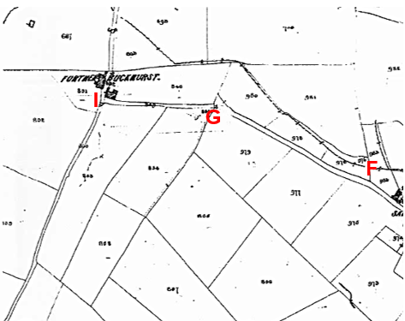
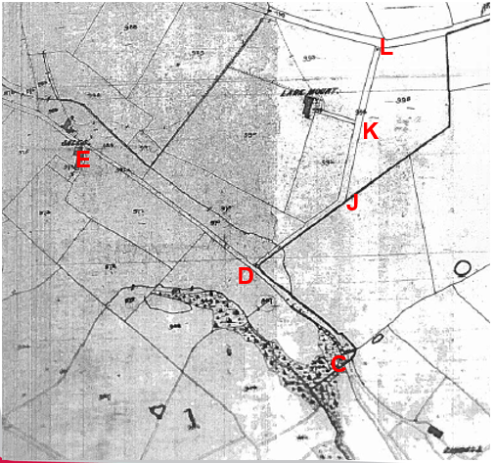
Observations |  | The copy of the Tithe Map for Walmersley with Shuttleworth deposited in the County Records Office is in a fragile condition and is not available for inspection.  Lancaster University hold a black and white copy of part of the Tithe Map obtained from The National Archives on microfilm. The map appears incomplete and it is not known whether the whole of the township was mapped or whether part was left unmapped as it was not necessary to map barren land which was not subject to tithes.  The Tithe Map shows the full length of Sales's Lane as a bounded route. Between point A and point C the route lies outside the boundary of the Township of Walmersley with Shuttleworth but is shown to physically exist on the map.  Between point C and point G Sales's Lane is shown and is numbered 981a on the map and is described in the Tithe Award as an occupation road listed under 'ownership' as 'Glebe land' and as being occupied by the Reverend Geoff Hornby. No tithes are listed as being payable.  The section between point G and point I is also shown on the Tithe Map and is given the number 849. It is listed in the Tithe Award as an occupation road owned by Margaret Jackson under leasehold from the Earl of Derby and no tithes are listed as being payable.  The route between points D-L is shown as a bounded track providing access to Lark Mount and connecting to Bridleway 206 (Croston Close Road) at point L. It is numbered 994 on the Tithe map and is described in the Award as an occupation road. It was not possible to read the name of the landowner in the Tithe award but it was listed as being owned under a leasehold from the Earl of Derby and no tithes were payable.  The article of agreement at the start of the Tithe Award clearly specifies that public roads were exempt from the payment of tithes.  The Tithe Award does not list any 'public roads' and an examination of the Tithe Map shows that the main public vehicular highways through the former townships were turnpike roads in the 1840s and that they are numbered and listed as 'turnpike roads' in the Award.  All other roads mentioned in the Award are described as 'occupation roads' with one route in Shuttleworth simply listed as 'road' and one plot listed as 'old highway' in Walmersley.  All the routes listed as 'occupation roads' were listed as being owned and occupied – many of them specified as being owned under leasehold from the Earl of Derby. No tithes were listed as being payable for any of them.
Investigating Officer's Comments |  | By the way they are shown on the Tithe Map both routes appear to have been wide enough to be used by vehicles in 1840 and are shown providing access to a number of properties and linking to other routes.  The meaning of the term 'occupation road' is not given but as the prelude states no tithes were payable on 'public roads' yet this phrase was not used within the Award, most roads being referred to as 'occupation road' and no tithe is recorded against them; this is consistent with Sales's Lane being a public road (although as there are other reasons for no tithe being payable this is not strong evidence).
Inclosure Act Award and Maps |  | Inclosure Awards are legal documents made under private acts of Parliament or general acts (post 1801) for reforming medieval farming practices, and also enabled new rights of way layouts in a parish to be made. They can provide conclusive evidence of status.
Observations |  | There is no Inclosure Award for the area affected by the Application.
Investigating Officer's Comments |  | No inference can be drawn.
Cassini Map, Series 109 - Manchester | 1842-4 | Extract of Map Sheet 109 originally published 1842-44 and provided by the Applicant.  The Cassini publishing company produced maps based on Ordnance Survey mapping. These maps have been enlarged and reproduced to match the modern day 1:50, 000 OS Landranger Maps and are readily available to purchase.
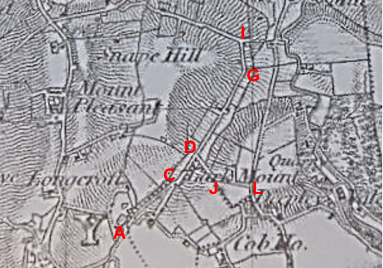
Observations |  | Sales's Lane and the route between points D – L are both clearly visible on the map. Lark Mount is shown to exist with access to it being from the route under investigation between point J and point L.
Investigating Officer's Comments |  | The original scale of the map (1 inch to the mile) means that only the more significant routes are generally shown. The purpose of the map in the late 1800s would probably have been to assist the travelling public on horseback or vehicle suggesting that the through roads shown had public rights for those travellers.
6 Inch Ordnance Survey (OS) Map | 1851 | The earliest Ordnance Survey 6 inch map for this area surveyed in 1844-48 and published in 1851.
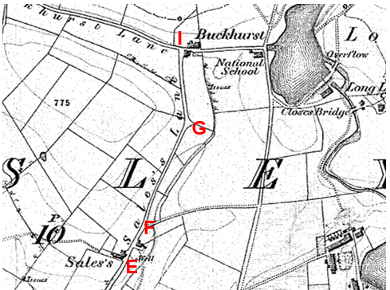
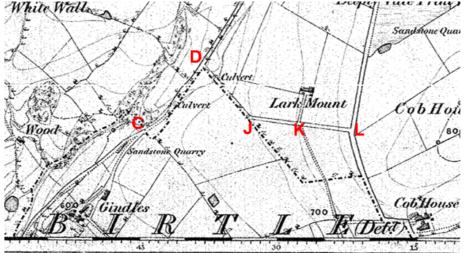
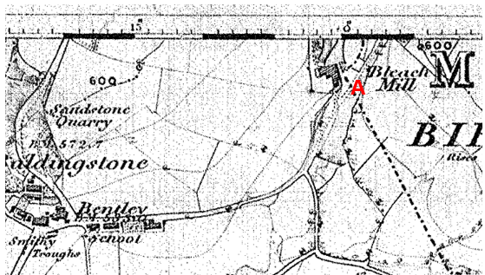
Observations |  | Both routes under investigation are shown as substantial routes on the map. Sales's Lane is named on the map between point E and point I and the routes are shown to provide access to a number of properties – Gindles, Sales's, Buckhurst and Lark Mount - and to form part of longer routes that connect to other named lanes (Buckhurst Lane and Croston Close Road). No gates or restrictions are shown limiting access along the routes.
Investigating Officer's Comments |  | Both routes existed and appeared to be capable of being used in 1851. They provided access to a number of properties but more importantly connected to other 'through' routes. Other less significant routes (marked by single or double pecked lines) are shown to connect to or to cross the routes (for example at point F and point K) – many of which are now recorded as public footpaths.  Of note is the fact that Sales's Lane is clearly named on the map and all the other named routes on this sheet are recorded as (or in the case of Buckhurst Lane have evidence for) public bridleway or carriageway.
25 Inch OS Map | 1895 | The earliest OS map at a scale of 25 inch to the mile. Surveyed in 1891 and published in 1893 and reprinted in 1895.
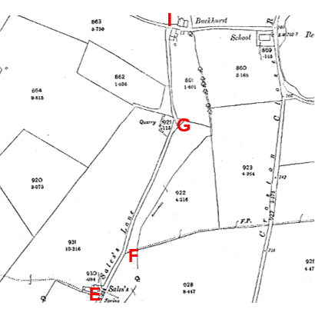
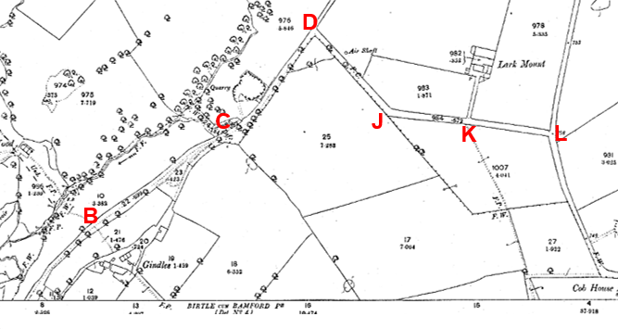
Observations |  | The First Edition 25" is at a larger scale than the 6" map showing the area in more detail.  Both routes under investigation are clearly shown on the map as substantial routes bounded from the adjacent land. Sales's Lane is named on the map and there are no gates or other barriers shown across either of the routes.  The routes are not coloured or shaded to indicate public status but neither are other routes now recorded as public bridleways or vehicular highways.
Investigating Officer's Comments |  | Both routes under investigation existed in 1895 and appeared to be capable of being used.  Sales's Lane is clearly named on the map which is consistent with it being more than footpath; all the other named routes on this sheet are recorded as (or in the case of Buckhurst Lane have evidence for) public bridleway or carriageway.  Shading was often used to show the administrative status of roads on 25 inch maps prepared between 1884 and 1912. All metalled public roads for wheeled traffic kept in good repair by the highway authority were to be shaded and shown with thickened lines on the south and east sides of the road. The routes under investigation are not shown in such a way but neither are other known public vehicular highways in the area so no inference can be drawn in this respect.
6 inch OS Map | 1894 | Further edition of the 6 inch map surveyed in 1891 and published in 1894.
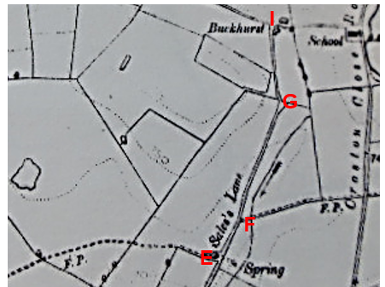
Observations |  | Both routes under investigation are clearly shown on the map as substantial routes connecting to other vehicular highways and bridleways. A number of less substantial routes – now recorded as public footpaths – are shown (as footpaths) to connect to them, for example at point E and point F. Sales's Lane is again named on the map.
Investigating Officer's Comments |  | The routes under investigation existed in 1894 and appeared to be part of the road network.
Cassini reprint of 1 inch Map of Lancashire | Originally published 1903 | Map extract submitted by the applicant. An enlarged reprint of a map first published in 1903 and based on the OS 1 inch mapping.
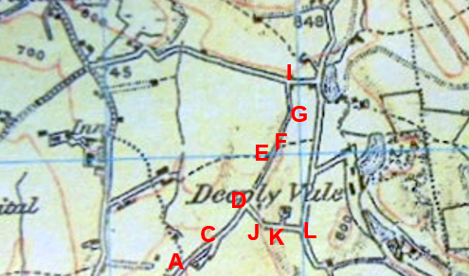
Observations |  | Both routes under investigation are clearly shown. Both routes are shown to connect to other substantial routes.
Investigating Officer's Comments |  | Both routes were considered to be sufficiently important to be included on a commercially produced small scale map sold to the public suggesting not only that they existed but that they were capable of being used by the public in 1903.
Bartholomew ½ inch Map Sheet 8 – Liverpool & Manchester | 1904 | The publication of Bartholomew's half inch maps for England and Wales began in 1897 and continued with periodic revisions until 1975. The maps were very popular with the public and sold in their millions, due largely to their accurate road classification and the use of layer colouring to depict contours. The maps were produced primarily for the purpose of driving and cycling and the firm was in competition with the Ordnance Survey, from whose maps Bartholomew's were reduced. An unpublished Ordnance Survey report dated 1914 acknowledged that the road classification on the OS small scale map was inferior to Bartholomew at that time for the use of motorists.
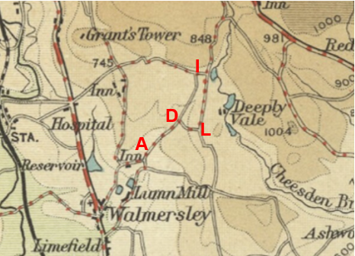
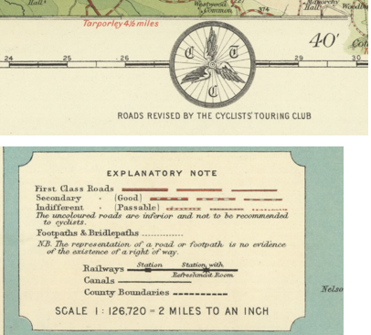
Observations |  | Both routes under investigation are clearly shown connecting to other substantial routes. Between point A and point D and point D and point L the route is shown as part of a longer route which has been marked up as being considered to be roads that are passable. Uncoloured are said in the key to be inferior and not recommended to cyclists.
Investigating Officer's Comments |  | The early 1900s saw a significant increase in the use of motorised vehicles and the classification of minor roads was constantly being revised by Bartholomew as some routes were improved to cope with the increasing traffic and others were virtually abandoned and fell into disrepair. Before 1920, few roads other than main roads were tarred but the travelling public had lower expectations of surface conditions than today and it would not be uncommon for an unsealed road, at the time considered adequate for horse drawn vehicles or early motor cars, to be shown.  The route under investigation is shown on the map supporting the view that it physically existed in the early 1900s.  The map contains the logo of the Cycling Touring Club who were known to have an arrangement with Bartholomew regarding the revision of the maps.  The route between points A-D and D-L appears to have been considered a public road and although the condition of the surface was said to be indifferent but passable the inference from its inclusion is that it was being used – at least by cyclists at that time. The remaining section between point D and I is shown to exist but the condition of the surface was perhaps inferior to the route between D to L which provided access to and from Croston Close Road (public bridleway). Cyclists were only allowed to use public carriageways at that time.
½ inch OS Map of Preston | 1907 | Further edition of the OS mapping.
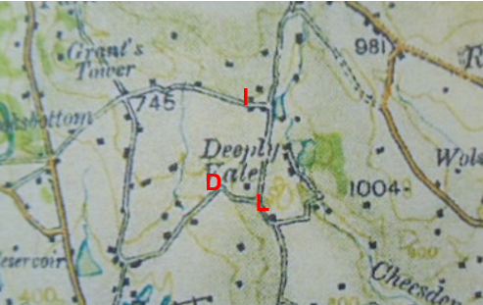
Observations |  | Part of Sales's Lane is shown as a continuation of Bentley Lane through point A to point D but the section of the route from point D past Sales's Farm to Buckhurst Road at point I is not shown.  The route from point D to point L – connecting to Croston Close Road – is shown.
Investigating Officer's Comments |  | This ½ inch scale map covered a large area and due to its scale could only show main routes. Public footpaths are not generally shown and neither are field boundaries. The map would have been sold primarily to the public travelling by vehicle or horseback and parts of the route under investigation are shown. The section of Sales's Lane between point D and point I is not shown although later Ordnance Survey mapping shows that the route still existed. The fact that it was not shown on this map may have reflected the fact that use was less significant in 1907 and that the more commonly used route was A-D-L. This reflects what was shown on the Bartholomew's map using feedback from cyclists.
25 inch OS Map | 1910 | Further edition of the 25 inch map surveyed in 1891, revised in 1908 and published in 1910.
Observations |  | Both routes under investigation existed in 1910 and appeared unaltered from the earlier edition of the 25 inch map.
Investigating Officer's Comments |  | The routes under investigation existed in 1910 and appeared to be capable of being used by the public on horseback or possibly vehicles.
Finance Act 1910 Map | 1910 | The comprehensive survey carried out for the Finance Act 1910, later repealed, was for the purposes of land valuation not recording public rights of way but can often provide very good evidence. Making a false claim for a deduction was an offence although a deduction did not have to be claimed so although there was a financial incentive a public right of way did not have to be admitted.  Maps, valuation books and field books produced under the requirements of the 1910 Finance Act have been examined. The Act required all land in private ownership to be recorded so that it could be valued and the owner taxed on any incremental value if the land was subsequently sold. The maps show land divided into parcels on which tax was levied, and accompanying valuation books provide details of the value of each parcel of land, along with the name of the owner and tenant (where applicable).  An owner of land could claim a reduction in tax if his land was crossed by a public right of way and this can be found in the relevant valuation book. However, the exact route of the right of way was not recorded in the book or on the accompanying map. Where only one path was shown by the Ordnance Survey through the landholding, it is likely that the path shown is the one referred to, but we cannot be certain. In the case where many paths are shown, it is not possible to know which path or paths the valuation book entry refers to. It should also be noted that if no reduction was claimed this does not necessarily mean that no right of way existed.
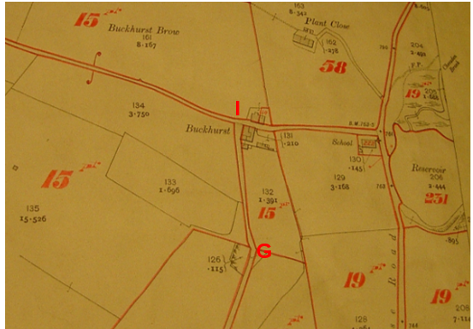
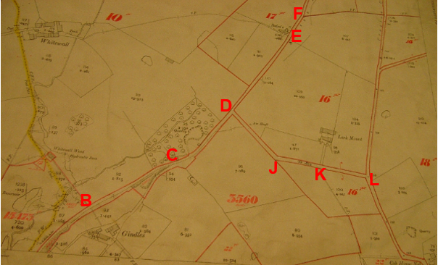
Observations |  | No Finance Act maps or valuation books were available in the Lancashire Records Office so the Finance Act maps were obtained from The National Archives.  An examination of the maps showed that both routes under investigation were clearly excluded from the adjacent numbered hereditaments and between point I and point G a numbered plot (plot 15) is clearly split by the route under investigation. Plot 16 is also split by the route under investigation between points J-K-L and in contrast the direct access to Lark Mount extending north from point J, but which would not form a public through route, has been included within plot 16.
Investigating Officer's Comments |  | The maps showed land in private ownership and, by implication, land not regarded as being sufficiently private to be taxable (i.e. included within numbered plots) including this route and it is considered that this was because the route was being used by the public.  In this instance the valuation books were not inspected as no part of the route under investigation was numbered.  The exclusion of the routes from the taxable hereditaments is good evidence of, but not conclusive of, public carriageway rights.  Numbered plots split by the route give further weight to the belief that Sales's Lane and the route D-L were considered to have public vehicular rights (as public footpaths and public bridleways were normally included within the numbered plots).  The fact that the direct access to Lark Mount north of point J is included as part of a numbered plot indicates that it was considered to be of a different status (providing private access specifically to Lark Mount) to the routes under investigation.
½ inch to the mile Geographia Road Map 30 miles around Manchester | Revised 1921 | Extract of map provided by applicant.
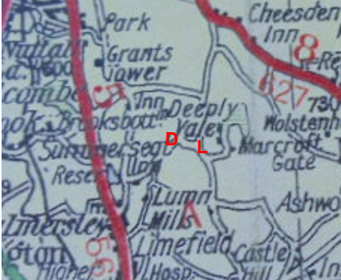

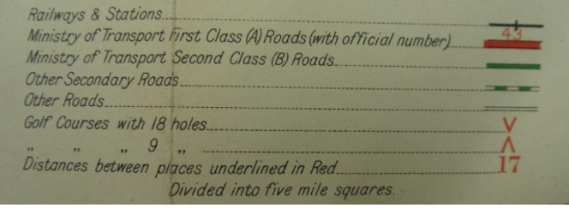
Observations |  | No properties are shown in the proximity of the routes and it appears that only part of the routes under investigation are shown. A road corresponding to route of Bentley Lane and continuing through point A (exact location not possible to pinpoint on the map) through to point D is shown and is depicted in the key as 'other roads'. Sales's Lane from point D to point I is not shown – the land over which it crosses being partly obscured by the words 'Deeply Vale' but the route between point D and point L – connecting to Croston Close Road – is shown.
Investigating Officer's Comments |  | The scale of the map means that it is likely that only the most significant public routes where shown and were differentiated in the key.  The same sections of the route are shown as were depicted on the 1907 ½ inch OS Map detailed above.  The fact that those parts of the route under investigation which are shown are considered to be 'Other Roads' suggests that they were considered at that time to be carrying public vehicular rights.
Abel Heywood & Sons Cycling & Touring Map 60 miles about Manchester  ½ inch to the mile |  | Extract of the map provided by the applicant. Undated but thought to be dated circa 1920 by a local historian.
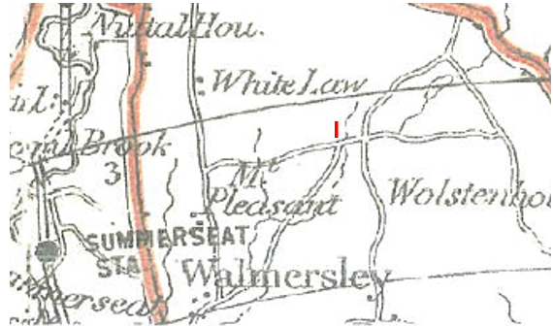
Observations |  | Sales's Lane is shown as part of a longer route from Walmersley through to Buckhurst Road at point I. The route between point D-L is not shown. Due to the scale of the map no properties in proximity to the routes are shown and routes are not named.
Investigating Officer's Comments |  | The fact that Sales's Lane is clearly shown on a cycling and touring map – the purpose of which was to show routes available to the public to use on a bike and with vehicles - suggests that it was considered to be a public road as cyclists were not allowed to use bridleways prior to 1968.
25 Inch OS Map | 1929 | Further edition of 25 inch map (re-surveyed 1891, revised in 1928 and published 1929.)
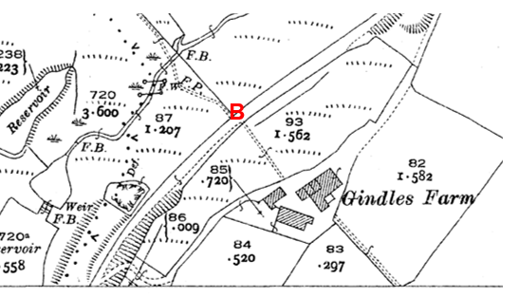
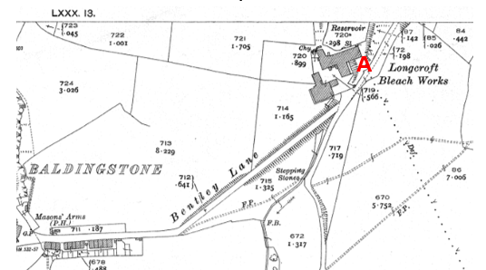
Observations |  | The full length of the routes under investigation are shown and Sales's Lane is named on the map. There are no changes to how the routes are shown from the earlier editions of the 25 inch Ordnance Survey Maps. An additional access from Sales's Lane to Grindles Farm is shown north of point A.
Investigating Officer's Comments |  | The routes under investigation still provided access to a number of properties along them but also through routes connecting to other public routes in the valley.
Authentic Map Directory of South Lancashire by Geographia | Circa 1934 | An independently produced A-Z atlas of Central and South Lancashire published to meet the demand for such a large-scale, detailed street map in the area. The Atlas consisted of a large scale coloured street plan of South Lancashire and included a complete index to streets which includes every 'thoroughfare' named on the map. The publisher claimed to have incorporated new districts, streets and trunk roads in the atlas and acknowledges the assistance of municipal and district surveyors when compiling the book.
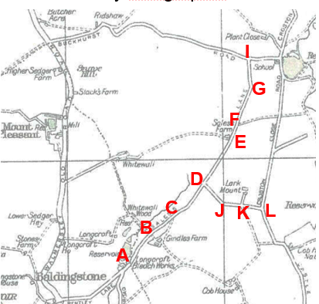
Observations |  | Both routes under investigation are clearly shown in the atlas and Sales's Lane is named.
Investigating Officer's Comments |  | The routes under investigation are shown in the atlas consistent with other routes proven or suspected as carrying public vehicular rights.
Aerial Photograph | 1940s | The earliest set of aerial photographs available was taken just after the Second World War in the 1940s and can be viewed on GIS. The clarity is generally very variable.
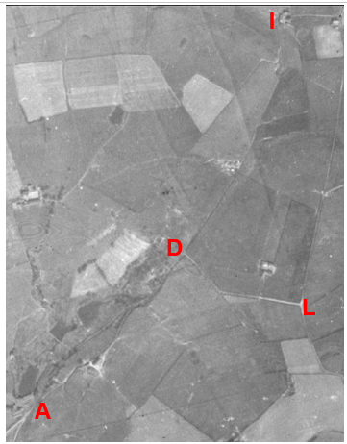
Observations |  | The quality of the photograph is poor but both routes under investigation can be seen. Sales's Lane between point D and point I is a faint track. The route between point D and point L shows up well on the photograph.  Boundary walls, fences, gates etc. cannot be seen on the photographs.
Investigating Officer's Comments |  | The routes under investigation existed in the 1940s. Sales's Lane between point D and point I is a faint track suggesting that vehicular use of this section may have been quite low in the 1940s.
6 Inch OS Map  (SD 81NW and SW) | 1956 | The OS base map for the Definitive Map, First Review, was published in 1956 at a scale of 6 inches to 1 mile (1:10,560). This map was revised before 1930 and is probably based on the same survey as the 1930s 25-inch map.
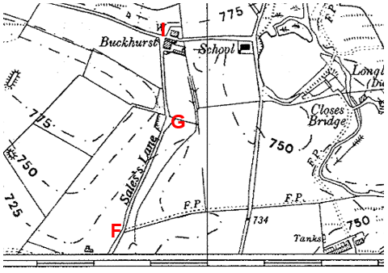
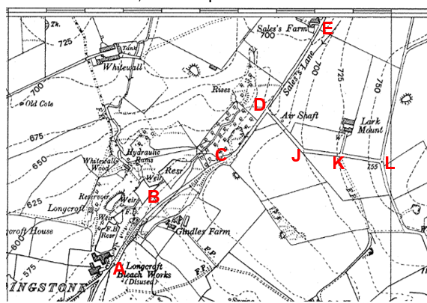
Observations |  | Both routes under investigation are shown on the map and Sales's Lane is named. No gates are shown across the route and properties located along the routes or accessed from the routes are named.
Investigating Officer's Comments |  | The routes under investigation physically existed and appeared capable of being used when the map was revised in the 1930s.
1:2500 OS Map | 1963 | Further edition of 25 inch map reconstituted from former county series and revised in 1962 and published 1963 as national grid series.
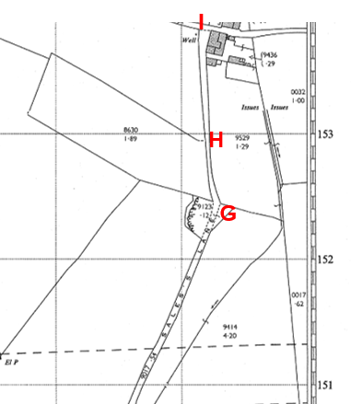
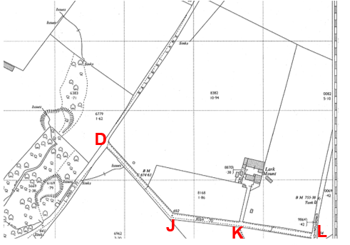
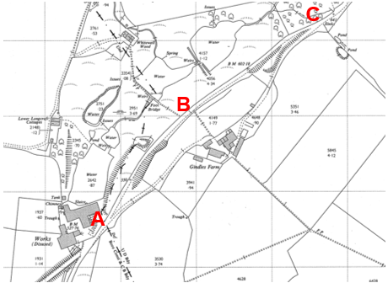
Observations |  | Both routes under investigation are shown. Access to Gindles Farm has been further altered to leave Sales's Lane just north of point A. Sales's Lane is named on the map.
Investigating Officer's Comments |  | The routes under investigation physically existed and appeared capable of being used when the map was revised in 1962.
Aerial photograph | 1960s | The black and white aerial photograph taken in the 1960s and available to view on GIS.
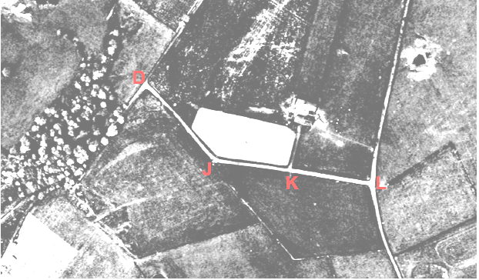
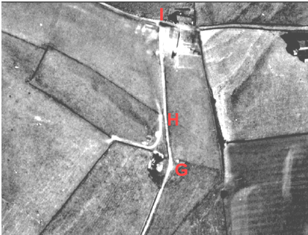
Observations |  | Sales's Lane is clearly visible with exception of most of the section between point A and point C which is obscured by tree cover.  The route between point D-L is clearly visible and both routes appear to be being used by vehicles.
Investigating Officer's Comments |  | The routes under investigation physically existed and appeared capable of being used in the 1960s.
Aerial Photograph | 2000 | Colour photograph taken in 2000 and available to view on GIS.
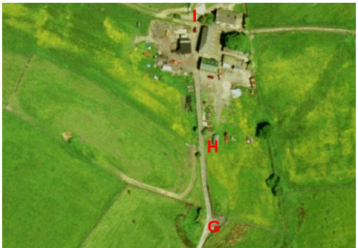
Observations |  | Both routes under investigation can be seen as substantial tracks consistent with the appearance of routes used by vehicular traffic with the exception of the first part of Sales's Lane between point A and point C which is not visible due to tree cover. No gates can be seen across the routes.
Investigating Officer's Comments |  | The routes under investigation physically existed and appeared capable of being used in 2000.
Definitive Map Records |  | The National Parks and Access to the Countryside Act 1949 required the County Council to prepare a Definitive Map and Statement of Public Rights of Way.  Records were searched in the Lancashire Records Office to find any correspondence concerning the preparation of the Definitive Map in the early 1950s.
Parish Survey Map | 1950-1952 | The initial survey of public rights of way was carried out by the parish council in rural district council areas and the maps and schedules were submitted to the County Council. In the case of urban districts and municipal boroughs the map and schedule produced was used, without alteration, as the Draft Map and Statement.
Observations |  | The routes under investigation are within Ramsbottom which was a municipal borough in the early 1950s so a parish survey map was not compiled.
Draft Map |  | The Draft Maps were given a “relevant date” (1st January 1953) and notice was published that the draft map for Lancashire had been prepared. The draft map was placed on deposit for a minimum period of 4 months on 1st January 1955 for the public, including landowners, to inspect them and report any omissions or other mistakes. Hearings were held into these objections, and recommendations made to accept or reject them on the evidence presented.
Observations |  | The routes under investigation were shown on the Draft Map as public footpaths and numbered as 208 and 245. No objections or representations were made to the County Council about the inclusion of the routes as public footpaths.
Provisional Map |  | Once all representations relating to the publication of the draft map were resolved, the amended Draft Map became the Provisional Map which was published in 1960, and was available for 28 days for inspection. At this stage, only landowners, lessees and tenants could apply for amendments to the map, but the public could not. Objections by this stage had to be made to the Crown Court.
Observations |  | The routes under investigation were shown in the same way on the Provisional Map as on the Draft Map and no representations were made to the County Council.
The First Definitive Map and Statement |  | The Provisional Map, as amended, was published as the Definitive Map in 1962.
Observations |  | The routes under investigation were shown in the same way on the First Definitive Map as on the Draft and Provisional Maps.
Revised Definitive Map of Public Rights of Way (First Review) |  | Legislation required that the Definitive Map be reviewed, and legal changes such as diversion orders, extinguishment orders and creation orders be incorporated into a Definitive Map First Review. On 25th April 1975 (except in small areas of the County) the Revised Definitive Map of Public Rights of Way (First Review) was published with a relevant date of 1st September 1966. No further reviews of the Definitive Map have been carried out. However, since the coming into operation of the Wildlife and Countryside Act 1981, the Definitive Map has been subject to a continuous review process.
Observations |  | The routes under investigation were shown in the same way on the Definitive Map of Public Rights of Way (First Review) as they had previously been shown.
Investigating Officer's Comments |  | From 1953 through to 1975 there is no indication that the routes under investigation were considered to be of any higher status than public footpath by the Surveying Authority. There were no objections to the depiction of the status of the routes from the public when the maps were placed on deposit for inspection at any stage of the preparation of the Definitive Map.
Statutory deposit and declaration made under section 31(6) Highways Act 1980 |  | The owner of land may at any time deposit with the County Council a map and statement indicating what (if any) ways over the land he admits to having been dedicated as highways. A statutory declaration may then be made by that landowner or by his successors in title within ten years from the date of the deposit (or within ten years from the date on which any previous declaration was last lodged) affording protection to a landowner against a claim being made for a public right of way on the basis of future use (always provided that there is no other evidence of an intention to dedicate a public right of way).  Depositing a map, statement and declaration does not take away any rights which have already been established through past use. However, depositing the documents will immediately fix a point at which any unacknowledged rights are brought into question. The onus will then be on anyone claiming that a right of way exists to demonstrate that it has already been established. Under deemed statutory dedication the 20 year period would thus be counted back from the date of the declaration (or from any earlier act that effectively brought the status of the route into question).
Observations |  | There are no Highways Act 1980 Section 31(6) deposits lodged with the County Council for the area over which the routes under investigation run.
Investigating Officer's Comments |  | There is no indication by any landowners under this provision of non-intention to dedicate public rights of way over their land.
Highway Adoption Records including maps derived from the '1929 Handover Maps' | 1929 to present day | In 1929 the responsibility for district highways passed from district and borough councils to the County Council. For the purposes of the transfer, public highway 'handover' maps were drawn up to identify all of the public highways within the county. These were based on existing Ordnance Survey maps and edited to mark those routes that were public. However, they suffered from several flaws – most particularly, if a right of way was not surfaced it was often not recorded.  A right of way marked on the map is good evidence but many public highways that existed both before and after the handover are not marked. In addition, the handover maps did not have the benefit of any sort of public consultation or scrutiny which may have picked up mistakes or omissions.  The County Council is now required to maintain, under section 31 of the Highways Act 1980, an up to date List of Streets showing which 'streets' are maintained at the public's expense. Whether a road is maintainable at public expense or not does not determine whether it is a highway or not.
Observations |  | Neither of the routes under investigation are recorded as being publicly maintainable on the List of Streets by the County Council.
Investigating Officer's Comments |  | No inference can be drawn regarding public rights.

The affected land is not designated as access land under the Countryside and Rights of Way Act 2000 and is not registered common land.

Landownership

The majority of the ownership of the route under investigation is not registered with the Land Registry and the ownership of the same is not known. The remaining sections of the route are registered to a number of different owners as follows:

- Peter Keith Snape and Gail Adrienne Snape, Grindles Lodge, Sales's Lane, Walmersley, Bury, Lancashire BL9 6TH

- Eileen Ann Little, Lark Mount Farm, Croston Close Road, Bury, Lancashire BL9 6TD

- Anthony Hugh Spencer and Heather Jayne Spencer, Gindles Farm, Sales's Lane, Bury, Lancashire BL9 6TH

- Bernard John Entwistle and Betty Entwistle, Gindles Cottage, Sales's Lane, Walmersley, Bury, Lancashire BL9 6TH

Part of the land on either side of the route under investigation is unregistered and the ownership is unknown. The remaining sections of the route are registered to a number of different owners as follows:

- Geoffrey Eric Roberts, Carol Roberts, Gareth John Roberts and Georgina Roberts, Sales's Lane Farm, Sales Lane, Bury, Lancashire BL9 6TH

- John Thomas Walsh and John Patrick Walsh, Buckhurst Farm, Walmersley, Bury, Lancashire BL9 6SZ

- Eric Stanley Entwistle, Lorne Entwistle and Gary Stewart Entwistle, Springside Farm, Springside Road, Walmersley, Bury, Lancashire BL9 5QU

- Stephen John Dale, Stand Lees Farm, Ashworth Road, Rochdale, Lancashire OL11 5UN

- Eileen Ann Little, Lark Mount Farm, Croston Close Road, Bury, Lancashire BL9 6TD

- Elizabeth Annie Howarth, Whitewall Farm, Walmersley Old Road, Nangreaves, Bury, Lancashire BL9 6SX

- John Frederick Sellers and Margaret Sellers, Cross Hall Farm, Mather Road, Bury, Lancashire BL9 6RB

- Formidable Capital Assets Limited, Bevis Green Works, Mill Road, Walmersley, Bury, Lancashire BL9 6RE

- Peter Keith Snape and Gail Adrienne Snape, Gindles Lodge, Sales's Lane, Walmersley, Bury, Lancashire BL9 6TH

Summary

The application was for the routes under investigation to be recorded as public bridleways. The applicant submitted a substantial amount of map and documentary evidence to support the application and also supplied user evidence which will be considered later in the report.

With regards to the physical characteristics of the routes it was noted that in August 2015 both routes were available to use. Signs at point D and point G indicated that horse riding was not allowed although it is not known how long theses signs had been in position. Gates at point H restricted (but did not prevent) access along the route.

Sales's Lane is shown as a through route on some small scale commercial maps (with the exception of Greenwood and Hennet) which were produced primarily to assist the travelling public which suggests that the route was considered to be a public route of at least bridleway status and probably a public vehicular route in the late 1700s and early 1800s.It is to be noted however that the routes are missing from Greenwoods and Hennets maps which are therefore inconsistencies in the story being indicated by the documentary evidence.

The 1824 Derby Estate plan shows Sales's Lane between point A and point G
as a 'High Road'. The purpose for which the plan was drawn is not known and the definition of 'High Road' is not given but it is clearly distinguished from 'Private Roads' suggesting that a route shown as a High Road was likely to carry public, probably vehicular, rights.

The 1840 Tithe Map shows Sales's Lane as 'occupation road' and is of substantial width.

Sales's Lane is named on the first edition of the Ordnance Survey 6 inch map and shown consistently from 1851 to the current day on all Ordnance Survey maps suggesting that it physically existed and does have some implication that those routes depicted were likely to be available for use. It was shown on the Bartholomew map as partly passable for cycles, the passable route then using D-L to Croston Close Road.

The exclusion of Sales's Lane from the taxable hereditaments, with numbered plots split by the route, is good evidence of public carriage rights.

Sales's Lane is a continuation of the vehicular Bentley Lane with no particular reason for rights to end at a modern administrative boundary.

The route between points D-L is not shown on any of the early commercial maps nor the Derby Estate plan dated 1824 suggesting that it may have come into existence after then as it is first shown on the 1840 Tithe Map, described as 'occupation road' with no tithe payable and then the first edition 6 inch Ordnance Survey Map and Cassini Map

The route is consistently shown from 1851 to the current day on all Ordnance Survey maps suggesting that it physically existed and was thus promoted to the travelling public to some extent.

The exclusion of the route from the taxable hereditaments with a numbered plot split by the route is good evidence of, but not conclusive of, public carriage rights.

Taking into account all of the map and documentary evidence examined it appears that there is evidence to suggest that both routes under investigation are of at least bridleway status and on balance, although the matter is finely balanced, that a highway open to the public in all vehicles including carts and carriages has already been dedicated to public use. Such dedication may not have occurred at the same time as the early commercial maps suggest that Sales's Lane existed from at least the late 1700s whereas the route between point D and point L may only have come into existence in the mid 1800s.

However, if it is accepted that either of the routes under investigation has public carriageway rights the effect of the Natural Environment and Rural Communities Act 2006 would be to extinguish any public mechanically propelled vehicle rights as both routes were recorded as public footpaths at the commencement of the Natural Environment and Rural Communities Act 2006.

Head of Service – Legal and Democratic Services Observations

In support of the application the applicant has submitted copies of the following maps:

- 6" to 1 mile OS 1849
- 6" to 1 mile OS 1891
- 6" to 1 mile OS 1930
- 6" to 1 mile OS 1956
- 25" to 1 mile OS 1893
- 25" to 1 mile OS 1929
- Yates 1" 1786
- 1910 Finance Act Map
- Authentic Map Directory S Lancs 1931 to 1935
- Estates Plans Lord Derby 1785 to 1788 redrawn 1824
- Cassini 1844 OS 1"
- Cassini 1903
- Smith's 1802 map of Lancashire
- ½" to 1 mile OS Preston map 1907
- Geographic Road Map 30 miles around Manchester revised 1921 ½" to 1 mile
- Abel Heywood & Sons Cycling & Touring Map 60 miles around Manchester ½" to 1 mile

The applicant has also submitted 7 forms detailing use in support of this application, the evidence of these forms is set out below:

The years in which the users have known the route varies:
1955 – 2013 1959 – 2013 1965 – 2013 1979 – 2013 1988 – 2013 1989 – 2013 1991 – 2013

All 7 users have used the route on horseback, the years in which the users used the route varies:
1955 – 2013 1959 – 1960 1965 – 2013 1979 – 2013 1980 – 2011 1989 – 2013 1991 – 2010 1991 – 2011
The main reasons for using this route on horseback include for exercising horses, horse riding, including leisure riding, and leading horses. The users also used the route on horseback in order to get to the chapel and to visit friends. The main places that the users were going to and from include from Birtle to Buckhurst, from Walmersley to Buckhurst, as well as from Walmersley to Cheesden Bridge and Ashworth Valley.

The use of the route per year varies between users but includes 150 times, 100 times, 30 times, 24 times, and 10+ times. Other users have also used the route 2-3 times a week.

All of the 7 users have also used the route on foot. 1 of the users has used the route in a vehicle and another user has used the route on a motorcycle/in a vehicle. 1 of the users has also used the route by pony and trap.

6 users agree that the line has always run over the same route, 1 user did not provide a response. All 7 users state that there has been a gate along the route. Some users state that the gate exists at/after Buckhurst Farm and other users state that there is a gate when approaching Buckhurst Farm from the Sales's Farm side as well as when approaching the farm from the Buckhurst Old School side. 5 of the users stated that the gate(s) have never been locked however 2 stated that they have. 1 user stated that the gate was locked from March 2013 onwards. 6 of the users stated that they have never been prevented access to the route however 2 users stated that a post was put across the gate. 1 user stated that this post was not a problem as the larger gate to the side was unlocked and was usable however the other user states that this post rendered the gate inaccessible on horseback.
6 of the users have never worked for any landowner or a tenant over which the route passes, 1 user did not provide a response to either question.

6 users have never been stopped or turned back when using the route, 1 user was only stopped in March 2013. 6 users have never heard of anyone else being stopped or having to turn back when using the route. 5 of the users have never been told that the route they were using was not a public right of way, 1 user has been told that the route was not a public right of way but did not provide any further details, and 1 user did not provide a response to this question. 4 of the users stated that they have never seen any notices or any signs along the route, 1 user did not respond to this question, and 2 users stated that they have seen notices or signs on the route. 1 notice said 'no through road' the other user stated that in March 2013 there were signs which appeared stating 'no horse riding.' 5 of the users have never asked permission to use this route, 2 of the users did not provide a response to this question.

At the end of completing the user form, users are asked to provide any further information they think is relevant, this information is set out below:
- "I have never had any problems with the residents on this route."
- "I rode the route on my first pony from Birtle from 1989 to 1991. I moved my pony and purchased a second in 1991 and rode the route on him until retiring him in 2011. I purchased another pony in 1995 and rode him on the route from then until finding it blocked in March 2013."
- "From 1991 onwards I've helped my sister exercise her ponies until 2011 when one was retired."

Information from landowners

E Little –

A letter has been received from Ms E Little who makes the following comments. She mentions that, in terms of the boundary of her property which is affected by the application, she has the responsibility for a portion of footpath 245 (Larkmount Lane). Ms Little states that as she knew the status of footpaths were that they were for walkers only, she has been as vigilant as possible since moving into the premises in 1989 to ensure that only those cars and horse riders who had her permission passed along the footpath.

Soon after moving into the premises Ms Little both instructed a solicitor to approach any neighbours using Larkmount Lane to ensure they had permission to use cars as well as personally contacting people living in the area to confirm the status of footpath 245. A letter (Letter 1) has been enclosed in Ms Little's letter as an example of the above from 1991.

A second letter has also been enclosed, that of Ms Little's reply to the Traffic Commissioners in 2007. This sets out the history of the area and use of the footpath including that initially it was not used generally for vehicles except for farm traffic and a couple of residents requiring access. However, in the 1980's, subsidence problems on the FP229 caused cars to begin using this route as an alternative. From then until 2000 the route was used mainly by farm vehicles and a few cars, mainly for access. In 2000 a Mr Ashe was granted an operators licence and the route was changed from a single track to a two lane road. The route over the years has been continually widened by lorries swinging into the verges and by Mr Ashe. In doing that, as well as through bringing commercial vehicles down the route which was too tight for lorries, Mr Ashe caused damage to Ms Little's property.

Ms Little states that even before she moved into the premises the use of the footpaths was monitored by previous occupiers such as S Robinson who specifically granted access. Ms Little states that she still challenges vehicles that use the footpath for a means other than accessing local properties.

Furthermore, Ms Little states that footpath 208 is also dangerous. As a result of the above, Ms Little states that the expressed high volume of traffic on this route has made it unsafe for horse riding which an upgrade to a bridleway would result in.

John Walsh, Andrea Walsh and Richard Alan Walsh –

A letter has been received from S Marshall for P Wilson & Company, acting on behalf of John Walsh, Andrea Walsh and Richard Alan Walsh, who makes the following comments. Firstly it is expressed that the land north and south of Buckhurst Road, including part of Sales Lane, did not form part of Lord Derby's Estate and therefore there is a large part of the road omitted from the Estate Plan. Therefore, that evidence cannot be conclusive of any right of way.

Secondly, concerning the Finance Act 1910 Map, neither the valuation book nor the field book extract has been provided and therefore the map extract cannot be interpreted.

Thirdly, it is stated that there is nothing in either the draft map or statement nor the definitive map and statement for footpaths 252 and 208 to suggest that the public right of way is anything but a footpath.

Finally, the seven user evidence forms are also mentioned here as they are inconsistent with their clients' and a group of local landowner's recollections over the years. The Walsh family have lived at Buckhurst Farm since 1915 and have not seen horse riders pass along Sales Lane and Buckhurst Road since then other than their own horses and those who have had their permission. A number of local landowners and occupiers, including the clients here, are prepared to produce sworn statutory declarations to state the use of Sales Lane and Buckhurst Road since they have owned/occupied their properties.

Information from adjoining landowner
A letter has been received from the Roberts family, Mr G E Roberts, Mrs C Roberts, Mr G J Roberts and Miss G Roberts, who own the adjoining land affected by the application, they make the following comments. They firstly state that the applicant's documentation is inconclusive but provide no further details. Furthermore, they stated that the user evidence forms that have been submitted are from people who are friends of theirs or people well known to them who have had the Roberts family's permission.

Moreover, they state that as horse riders themselves they believe that the footpath is unsuitable for upgrade to a bridleway for several reasons. The first is that the lanes on the route are single track which few passing places and a number of blind bends. Also, in many places along the route there are high walls and deep ditches on either side of the lane. Furthermore, a number of properties on the route have this lane as their only access point and so this results in the lane becoming very busy for them. In addition, some properties have liveries and farm traffic and there is also refuse and postal services, couriers, building and fencing supplies delivery wagons, oil and gas tankers and visitors.

The footpath itself is tarmac and so this makes it very popular with walkers including dog walkers and those with young children/prams and so this route may become unsafe for them if there was an increase in horse traffic on the path.

Assessment of the Evidence

The Law - See Annex 'A'

In Support of Making an Order(s) for restricted byway status

- map and documentary evidence

Against Making an Order(s)

-inconsistent inclusion of the northerly section on the C19th commercial maps and the 1907 ½ inch OS

In support of Making an Order(s) for bridleway status

- map and documentary evidence
- user evidence

Against making an Order(s) for Bridleway status

- Reference to challenge and permissions if considering user evidence
- Low user numbers if considering user evidence.
- Some inconsistencies in the documentary evidence

Conclusion

The route under consideration is currently recorded as a public footpath. The application is to upgrade the sections of the footpath from points A-B-C-D-E-F-G-H-I and D-J-K-L to a bridleway, as it is suggested the public footpath carries higher public rights.

Committee should note that as the route already appears on the definitive map as a public footpath, it is not sufficient to satisfy the lesser test of reasonably alleging the existence of higher rights, neither is it necessary for there to be conclusive evidence of the existence of a higher public right than a public footpath, instead the standard of proof required is the balance of probability.

It is advised that as there is no express dedication in this matter that the Committee should consider, on balance, whether there is sufficient evidence from which to have its dedication inferred at common law from all the circumstances or for the criteria in S31 Highways Act 1980 for a deemed dedication to be satisfied based on sufficient twenty years "as of right" use to have taken place ending with this use being called into question. All evidence would appear to relate to the route A-B-C-D-E-F-G-H-I and D-J-K-L and therefore the evaluation is on this basis.

Looking firstly at whether dedication can be inferred on balance at common law it is advised that the Committee has to consider whether evidence from the maps and other documentary evidence coupled with the evidence on site does on balance indicate how the route should be recorded. The analysis of the map and documentary evidence by the Head of Service – Planning and Environment provides strong evidence suggesting that both routes A-B-C-D-E-F-G-H-I and D-J-K-L are of at least bridleway status and that on balance that a highway open to the public in all vehicles including carts and carriages has already been dedicated to public use. However, it is suggested that the dedication of the two routes may not have occurred at the same time as the whilst the early commercial maps suggest that Sales's Lane has existed since at least the late 1700s, the documentary evidence provided in respect of the route D-J-K-L suggests that this route did not come into existence until the mid 1800s.

On balance, the map and other documentary evidence is in itself considered sufficient to conclude that the route was a historic public vehicular highway and it is therefore suggested to committee that inferred dedication can on balance be satisfied. The effect of the Natural Environment and Rural Communities Act however is to extinguish more modern mechanically propelled rights leaving the route as able to be recorded as a restricted byway.

Should committee have any reservations as to the strength of the map and documentary evidence of a vehicular highway it may wish to also consider whether the documentary evidence points instead to bridleway status or whether deemed dedication under S31 Highways Act 1980 or inference at common law can be satisfied from the user of the route. There is some user evidence of use on horseback which would lead to consideration of the route as a bridleway rather than restricted byway given the type of use being evidenced.

Looking at the strength of the documentary evidence it is considered sufficient to conclude that the route was a historic vehicular route for the public.

Turning to user, Committee will be aware that in order to satisfy the criteria for S31, there must be sufficient evidence of use of the claimed route by the public, as of right and without interruption, over the twenty year period immediately prior to its status being brought into question, in order to raise a presumption of dedication. This presumption may be rebutted if there is sufficient evidence that there was no intention on the part of the landowner during this period to dedicate the route as a public right of way.

The first consideration is to determine whether the route is called into question. In this matter the evidence provided indicates different recollections about access having been prevented, particularly with regards to the location of and locking of gates and of the presence of, dates and knowledge of notices and signage. In this matter 7 user forms have been provided. Whilst there is reference by all 7 users to gates being present along the route, only 2 of the users state that the gates were locked with one user stating this to have been the case since March 2013. With the exception of the reference by 2 of the users to a post being placed across the gate with one those users stating that this rendered the gate inaccessible on horseback users do not appear to have been prevented access to the route with relative ease and frequency. None of the users state that they have ever asked permission to use the route with 6 of the users having no recollection of anyone else having been stopped or turned back. Only one user claims to have been stopped and turned back from using the route in March 2013. Another user states that they were informed that that the land was not public but provides no further detail in this regard. It is suggested that the user evidence does not provide sufficient evidence of dates as to when these events took place and therefore it is suggested on balance that the "calling into question" would be the application itself in 2013 and that the 20 year period under consideration would therefore be 1993 – 2013.

Looking at the twenty years 1993-2013, use by all 7 users dates back to 1993 with evidence of use being sufficiently frequent. Claimed use is predominantly on horseback including exercising horses, horse riding, including leisure riding and leading horses. Users also claim to have used the route on horseback to travel to the chapel and to visit friends. In addition to use of the route on horseback, 1 user has used the route in a vehicle, another on a motorcycle/in a vehicle and 1 by pony and trap.

There are however a relatively low number of users giving evidence of their use of a relatively long route. Their use has not just to have appeared trivial and sporadic.

Although a number of the landowners object to this application it is acknowledged by them that the route has been used on horseback, albeit they refer to persons known to them. Reference is made by Ms Little to having challenged users and allowing only horses and cars with her permission to pass along the portion of the route that she is responsible for. However, with the exception of one user claiming to have been stopped and turned back from using the route in March 2013 there are no other references in the user evidence to challenges having been made of users.

With reference to the concern about not getting Finance Act documentation for consideration by the committee, this is addressed in the analysis of the map and documentary evidence relating to the Finance Act 1910 Map as referred to in the consideration of documentary evidence section of the report.

On balance, it is suggested that in this matter it may be considered by committee, that there is sufficient evidence of use required for S31 or inference at common law of dedication of a bridleway stemming from modern use if it were not already considered to have been dedicated with higher vehicular rights.

However, taking all of the relevant information into account committee may be satisfied that on balance dedication as a vehicular route many years before can be inferred at common law and that an Order be made recognising restricted byway status and promoted to confirmation.

Risk Management

Consideration has been given to the risk management implications associated with this claim. The Committee is advised that the decision taken must be based solely on the evidence contained within the report, and on the guidance contained both in the report and within Annex 'A' included in the Agenda Papers. Provided any decision is taken strictly in accordance with the above then there is no significant risks associated with the decision making process.

Alternative options to be considered - N/A

Local Government (Access to Information) Act 1985

List of Background Papers

Paper | Date | Contact/Directorate/Tel
All documents on File Ref: 804-547 |  | Megan Brindle , 01772 535604, County Secretary and Solicitors Group
Reason for inclusion in Part II, if appropriate
N/A

The Ordnance Survey (OS) has produced topographic maps at different scales (historically one inch to one mile, six inches to one mile and 1:2500 scale which is approximately 25 inches to one mile). Ordnance Survey mapping began in Lancashire in the late 1830s with the 6-inch maps being published in the 1840s. The large scale 25-inch maps which were first published in the 1890s provide good evidence of the position of routes at the time of survey and of the position of buildings and other structures. They generally do not provide evidence of the legal status of routes, and carry a disclaimer that the depiction of a path or track is no evidence of the existence of a public right of way.
Aerial photographs can show the existence of paths and tracks, especially across open areas, and changes to buildings and field boundaries for example. Sometimes it is not possible to enlarge the photos and retain their clarity, and there can also be problems with trees and shadows obscuring relevant features.

